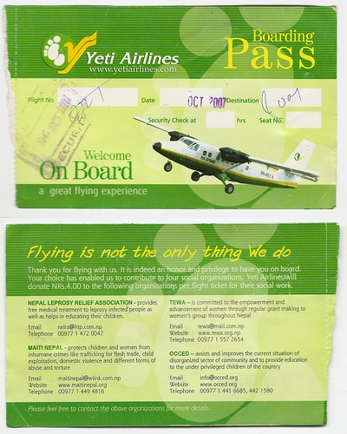

[This Photo](https://www.flickr.com/photos/44518317@N00/2101902744) by Unknown Author is licensed under [CC BY-SA-NC](https://creativecommons.org/licenses/by-nc-sa/3.0/)

INFORMATICS PRACTICES

By : Bhavesh Kolhe

Class : XII -B(Science)



DELHI PUBLIC SCHOOL, NASHIK

PRACTICAL FILE

Title of the Project : Air Reservation System

Subject : Informatics Practices

Name of the Student :Bhavesh Kolhe

Class : XII

Section:B

Roll No. Allotted by CBSE :

Name of the Teacher :Mrs. Seema Junnare

Name of the School :Delhi Public School

Session :2020-2021

__________ ___________ __________

Sign Sign Sign

(Subject Teacher) (External Examiner) (Principal

(Mrs. Seema Junnare) ( ) (Dr. Pushpy Dutt)

**TABLES OF CONTENTS**

1) CERTIFICATE

2) ACKNOWLEDGEMENT

3) PREAMBLE

4) OVERVIEW

5) OUTPUT AND CODING



DELHI PUBLIC SCHOOL, NASHIK

CERTIFICATE

This is to certify the **Mast. Bhavesh Kolhe** of Class **XII** Div **B** of **Delhi Public School, Nashik** has completed his project under my supervision. He has taken proper care and shown utmost sincerity in the completion of the project for the Subject **Informatics Practices.**

I certify that this project is up to my expectations and as per the guidelines of the CBSE

_____________ ___________ ______________

Sign Sign Sign

(Subject Teacher) (External Examiner) (Principal)

(Mrs. Seema Junnare) (________________) (Dr. Pushpy Dutt)

**ACKNOWLEDGEMENT**

I would like to express my deepest appreciation to all those who provided me this possibility to complete this project. It would not have been possible without their kind support and helped me.

I would like to extend my sincere thanks to my teacher **Mrs. Seema Junnare** of **Delhi Public School, Nashik** and Respected Principal **Dr.Pushpy Dutt** for their kind co-operation and encouragement which help me in completion of this project.

Without their constant supervision, guidance for providing necessary information regarding the project & support this project could not be completed.

My thanks and appreciations also go to my friends and family in developing the project and people who have willingly helped me out with their abilities.

**PREAMBLE**

The project titled “Air Reservation System” has been developed as per requirement of CBSE for the subject

Informatics Practices (065) for the year 2020-2021. The

source code has been developed in Python 3.7.6 and

Jupyter Notebook. The project deals with:

1) Creation of Air Reservation System in Python 3.7.6 module

2) Displaying option available in flight reservation in Jupyter Notebook

3) Inserting code in Jupyter Notebook

4) Selecting from various conditions in Jupyter

Notebook

5) Loading data

6) Moving from booking tickets, viewing food menu, calculating food bill, viewing ticket amount, calculating ticket amount and then complete bill of food and ticket in Jupyter Notebook

**OVERVIEW**

The following project has been designed with a deep insight into the working of the Air Reservation System.

Some of the salient features of the project are:

1) In the beginning, all the options are displayed available for flight booking. After that user needs to choose one option as per their requirement.

2) If the user enters 1 then it will display “to enter passenger data”. Then the user needs to enter name, journey date, source and destination. After that it will display “passenger data insertion completed”.

3) If the user enters 2 then it will display “to view the class type”.

It will display as “Do you want to see class type available: enter 1: for yes”. If the user enters 1 then it will display all the class type available in the flight booking .

4) If the user enters 3 then it will display “for ticket amount”. It will display “We have the following class for you:”. Then it will display the options as

“Enter 1: type is first class for RS 4000 per person\-

Enter 2: type is business class for RS 6000 per person\-

Enter 3: type is economy class for RS 2000 per person\-”

Then the user is asked to enter the choice and number of passenger. If user enters 1 it will displat as "you have opted First class" and it will display the calculated ticket amount. Similarly, for second and third option it will display the output.

5) If the user enters 4 then it will display “for viewing the food menu". It will display "Do you want to see the food menu available: enter 1 for yes:". If the user enters 1 it will display all the food items available with the flight.

6) If the user enters 5 then it will display “for food bill”.

It will display "Do you want to see the food menu available: enter 1: for yes". If the user enters 1 it will show all the food items. After that it asks the user to choice if the user enters 1 then it will display "you have ordered tea" and it asks for the how much quantity do you want and then it calculates the amount for your food item. Similar process for other order items as per the user’s choice.

7) If the user enters 6 then it will display “for complete amount".

Then the user needs to enter the name, food bill and ticket bill and after that it calculates your complete bill on online air reservation system and then if user enter 7 it will exit.

**OUTPUT AND CODING**

**#TABLES IN MYSQL**

1) Passenger data table:

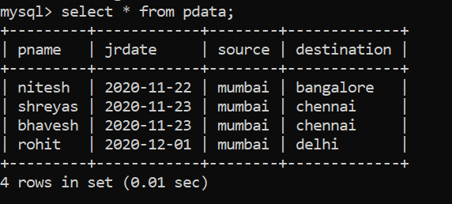

2) Class type table:

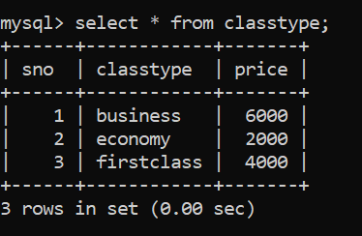

3) Food table:

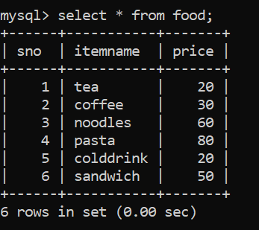

4) Bill table:

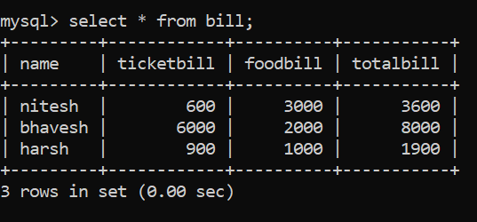

Code and Output window in Jupyter Notebook:

#code written in Jupyter notebook

1) Main screen : #1

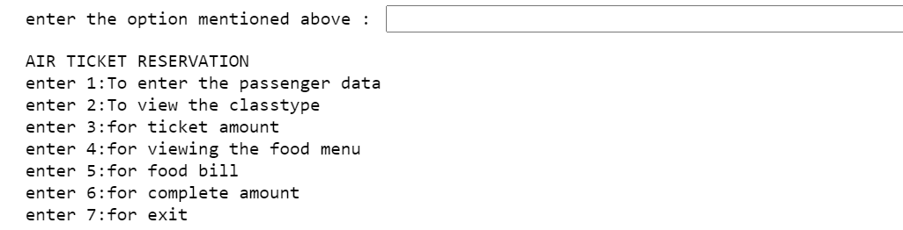

2) On selecting first option: #2

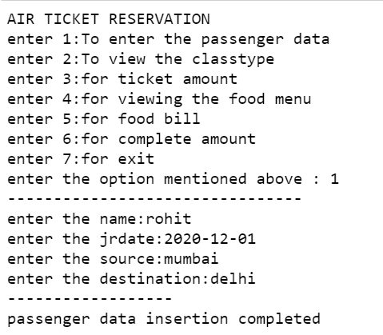

3) On selecting second option: #3

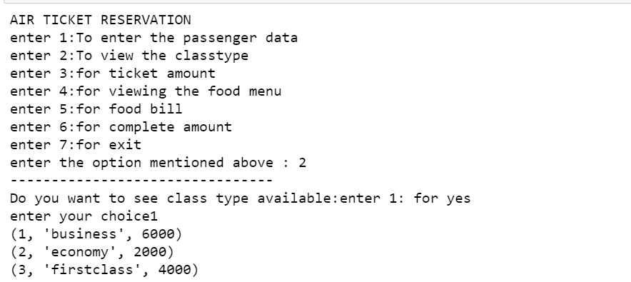

4) On selecting third option : #4

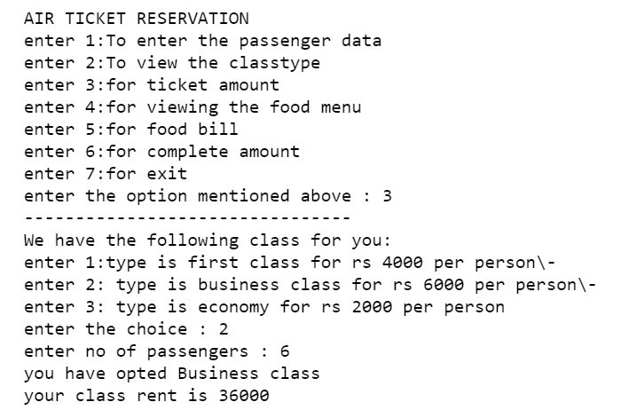

5) On selecting fourth option: #5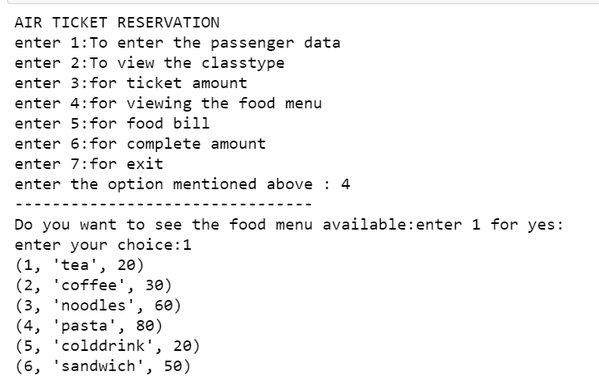

6) On selecting fifth option: #6

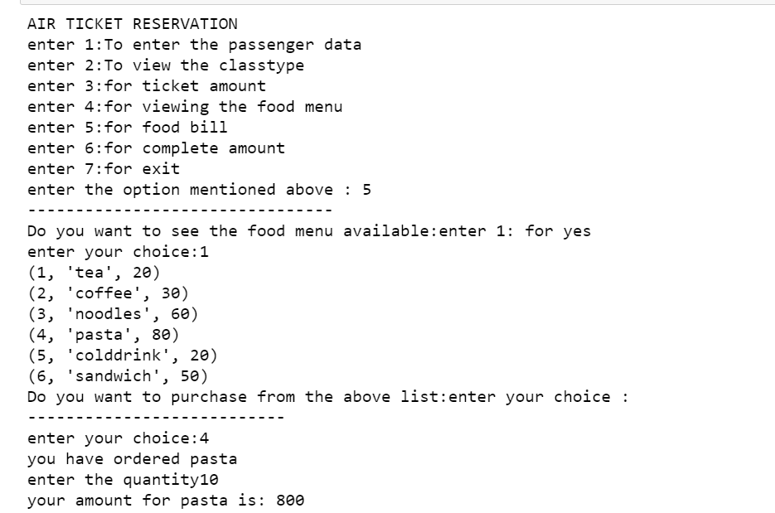

7) On selecting sixth option: #7

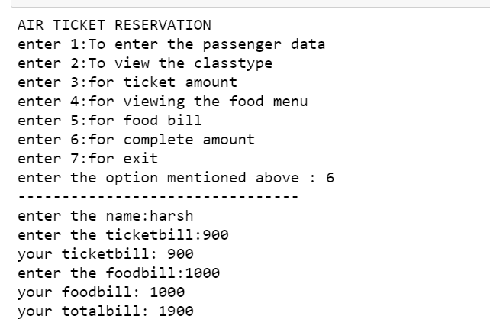

**CODING**

import os

import platform

import pandas as pd

import mysql.connector as sqltor

1) def menuset(): #1

import mysql.connector as sqltor

mycon=sqltor.connect(host='localhost',user='root',passwd='mysql',database='bhavesh')

cursor=mycon.cursor()

print("AIR TICKET RESERVATION")

print("enter 1:To enter the passenger data")

print("enter 2:To view the classtype")

print("enter 3:for ticket amount")

print("enter 4:for viewing the food menu")

print("enter 5:for food bill")

print("enter 6:for complete amount")

print("enter 7:for exit")

userchoice=int(input("enter the option mentioned above : "))

print("--------------------------------")

if(userchoice == 1):

registercust()

elif(userchoice == 2):

classtypeview()

elif(userchoice == 3):

ticketprice()

elif(userchoice == 4):

foodview()

elif(userchoice == 5):

foodbill()

elif(userchoice == 6):

completebill()

elif(userchoice == 7):

exit()

else:

print("enter the correct choice")

menuset()

2) def registercust(): #2

mycon=sqltor.connect(host='localhost',user='root',passwd='mysql',database='bhavesh')

cursor=mycon.cursor()

L=[]

name=input("enter the name:")

L.append(name)

jrdate=input("enter the jrdate:")

L.append(jrdate)

source=input("enter the source:")

L.append(source)

destination=input("enter the destination:")

L.append(destination)

cust=(L)

q="insert into pdata(pname,jrdate,source,destination)values(%s,%s,%s,%s);"

print("------------------")

print("passenger data insertion completed")

cursor.execute(q,cust)

mycon.commit()

3) def classtypeview(): #3

mycon=sqltor.connect(host='localhost',user='root',passwd='mysql',database='bhavesh')

cursor=mycon.cursor()

print("Do you want to see class type available:enter 1: for yes")

ch=int(input("enter your choice"))

if ch==1:

sql="select * from classtype"

cursor.execute(sql)

rows=cursor.fetchall()

for x in rows:

print(x)

4) def ticketprice(): #4

print("We have the following class for you:")

print("enter 1:type is first class for rs 4000 per person\-")

print("enter 2: type is business class for rs 6000 per person\-")

print("enter 3: type is economy for rs 2000 per person")

x=int(input("enter the choice : "))

n=int(input("enter no of passengers : "))

if(x==1):

print ("you have opted First class")

h=4000*n

print("your class rent is",h)

elif (x==2):

print ("you have opted Business class")

h=6000*n

print("your class rent is",h)

elif (x==3):

print ("you have opted Economy class")

h=2000*n

print("your rent is",h)

else:

print ("please choose a class type")

5) def foodview(): #5

mycon=sqltor.connect(host='localhost',user='root',passwd='mysql',database='bhavesh')

cursor=mycon.cursor()

print("Do you want to see the food menu available:enter 1 for yes:")

ch=int(input("enter your choice:"))

if ch==1:

sql="select * from food"

cursor.execute(sql)

rows=cursor.fetchall()

for x in rows:

print(x)

6) def foodbill(): #6

mycon=sqltor.connect(host='localhost',user='root',passwd='mysql',database='bhavesh')

cursor=mycon.cursor()

print("Do you want to see the food menu available:enter 1: for yes")

ch=int(input("enter your choice:"))

if ch==1:

sql="select * from food"

cursor.execute(sql)

rows=cursor.fetchall()

for x in rows:

print(x)

print("Do you want to purchase from the above list:enter your choice :")

print("---------------------------")

d=int(input("enter your choice:"))

if d==1:

print("you have ordered tea")

a=int(input("enter the quantity:"))

s=20*a

print("your amount for tea is:",s)

elif d==2:

print("you have ordered coffee")

a=int(input("enter the quantity:"))

s=30*a

print("your amount for coffee is:",s)

elif d==3:

print("you have ordered noodles")

a=int(input("enter the quantity:"))

s=60*a

print("your amount for noodles is:",s)

elif d==4:

print("you have ordered pasta")

a=int(input("enter the quantity"))

s=80*a

print("your amount for pasta is:",s)

elif d==5:

print("you have ordered colddrink")

a=int(input("enter the quantity:"))

s=20*a

print("your amount for colddrink is:",s)

elif d==6:

print("you have ordered sandwich")

a=int(input("enter the quantity:"))

s=50*a

print("your amount for sandwich is:",s)

else:

print("please enter your choice from the menu")

7) def completebill(): #7

mycon=sqltor.connect(host='localhost',user='root',passwd='mysql',database='bhavesh')

cursor=mycon.cursor()

L=[]

name=input("enter the name:")

L.append(name)

t=int(input("enter the ticketbill:"))

print("your ticketbill:",t)

L.append(t)

f=int(input("enter the foodbill:"))

print("your foodbill:",f)

L.append(f)

y=(t+f)

to=print("your totalbill:",(t+f))

L.append(y)

bill=(L)

q="insert into bill(name,ticketbill,foodbill,totalbill)values(%s,%s,%s,%s)"

cursor.execute(q,bill)

mycon.commit()